Reviews

Belhorizon Seychelles

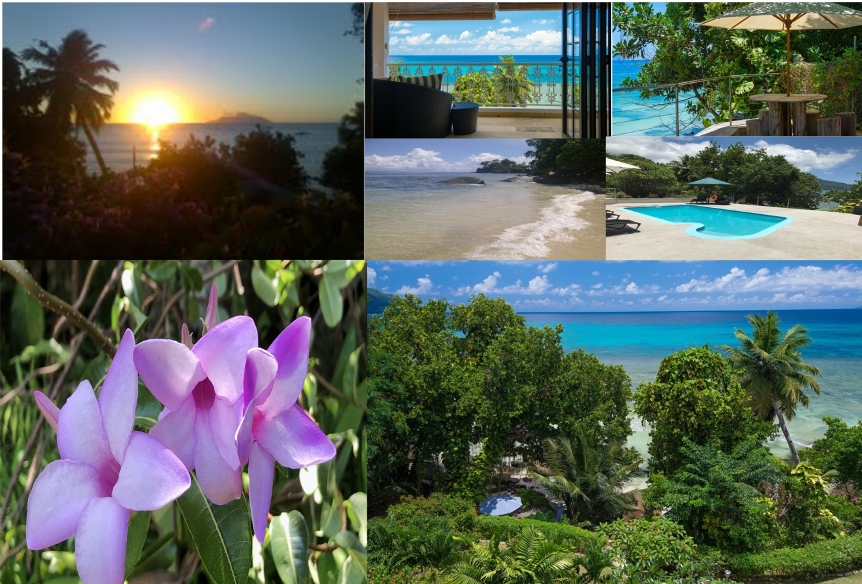

Sample reviews from past clients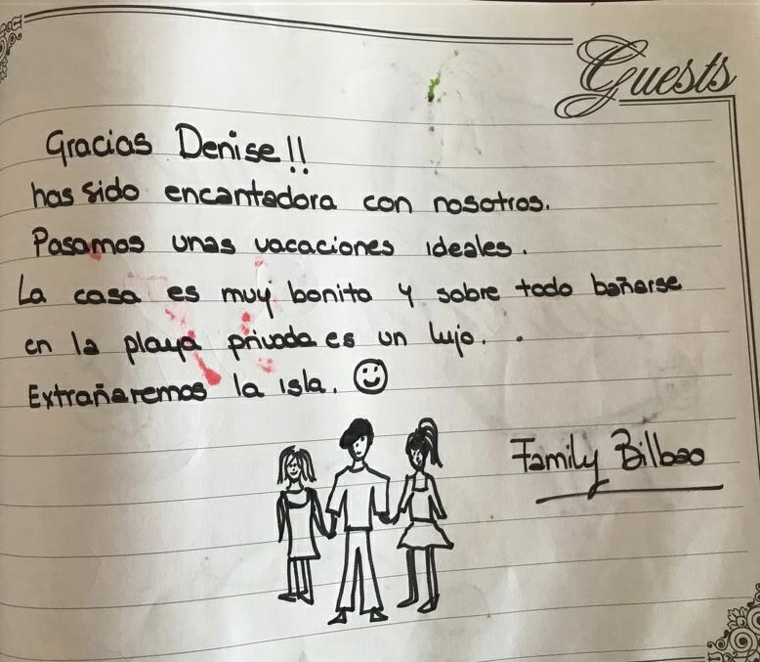

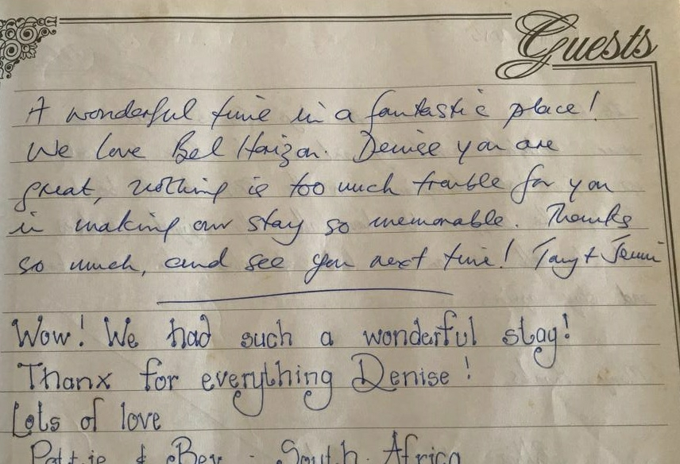

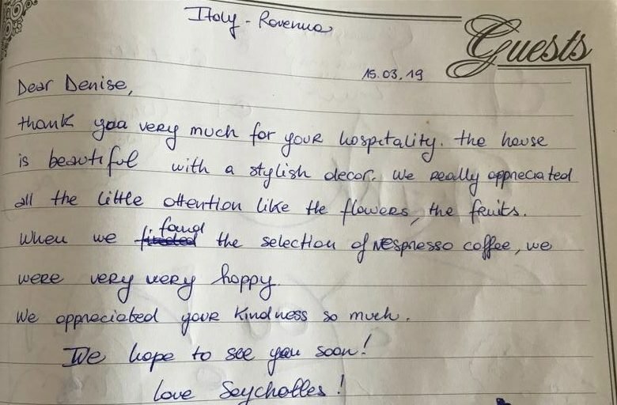

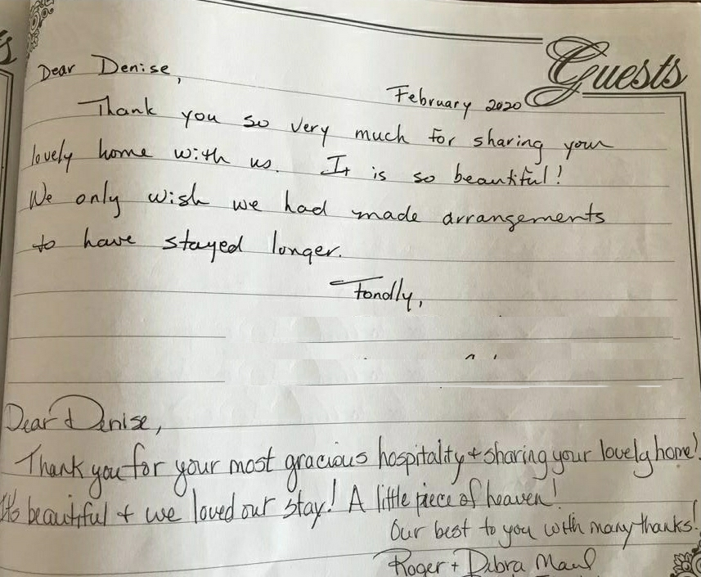

Contact us on email: [BelhorizonSeychelles@gmail.com](mailto:BelhorizonSeychelles@gmail.com) or Tel: +248 2520061